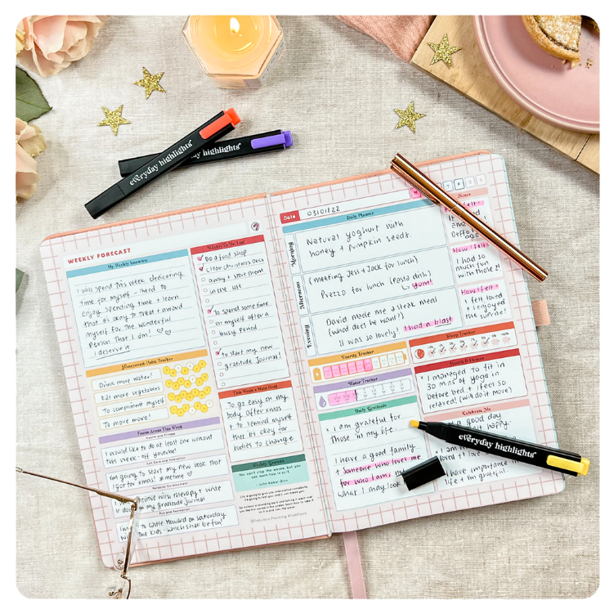

HEALTH DIARY

RYANA CALENDARS is selling wonderful OFFICE diaries in different colors and designs! It contains of great leather!

RS 810